NEW ATHLETE
AVUHSD ONLINE ATHLETIC CLEARANCE PROCESS

Step-by-step instructions for completing the online process with screenshots matching each step are listed below. An athletic physical (Blue Card) must be signed by a physician and on file in the athletics office (within one year or less of the date signed by a doctor). If you have any questions contact your school’s athletic secretary or athletic director. You will need insurance information and student present in order to complete the online process.
Screen-by-Screen Instructions
- Go to www.athleticclearance.com and click on “Register”.
- Fill in required information. Click “Submit” when finished.
*Be sure to remember your username and password for future use.
- Enter given code. Click “Submit”.
- Click on “Start Clearances Here”.
- Select school year as 2020-2021. Select your high school. Select sport. Click “Submit” when finished.
- Enter all required information. Click “Save” when finished.
- Do not upload any documents, just turn in physical document to athletics office. Click “Submit” to continue.
- Answer all yes or no questions. If the answer is yes to any question, type a brief description of the issue. Click “Save” when finished.
- Enter required parent/guardian information. Click “Submit” when finished.
- Read boxes and add all signatures for guardian and student. Click “Submit” when finished.
- Additional documents can be found on the confirmation page. These documents are also available in the athletics office.
- Once you reach the confirmation screen, the online clearance process is complete. At this time, you may add any additional sports the student is interested in trying out for. Mark the check box acknowledging parent/guardian electronic signature. We will finalize this acknowledgment with the signature on the physical form.

A confirmation email will be sent stating you have completed the online process, and another will be sent to you once the student is fully cleared. Athletic clearance is pending until physical is verified, academic eligibility is checked, and any transfer documentation is approved by CIF.

Screen Shots (Match numbers from above)
1  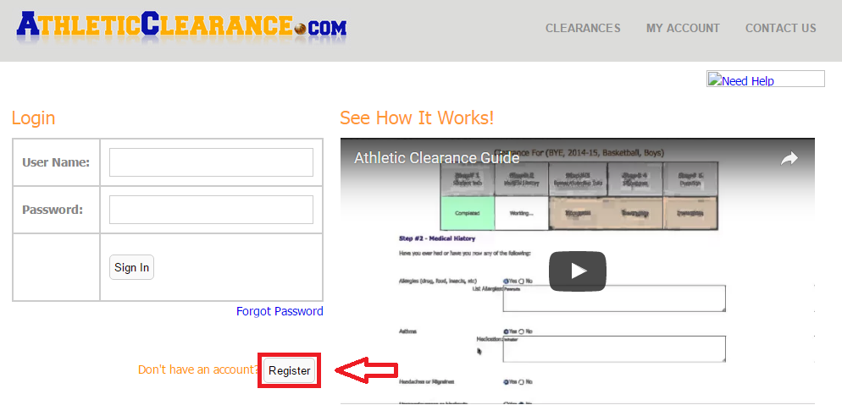 | 2  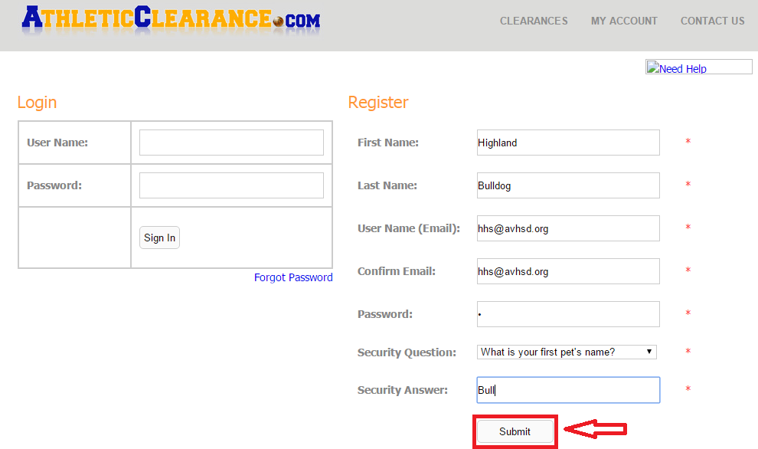
3  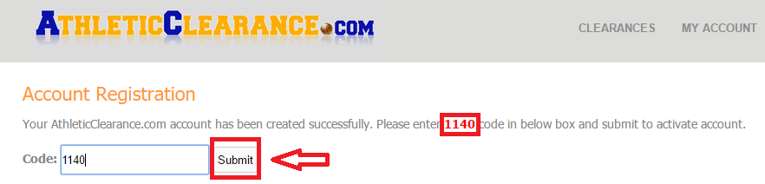 | 4  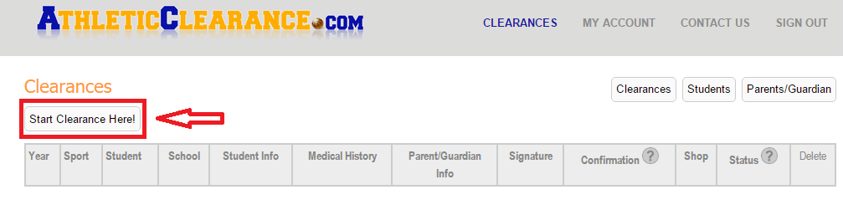
5  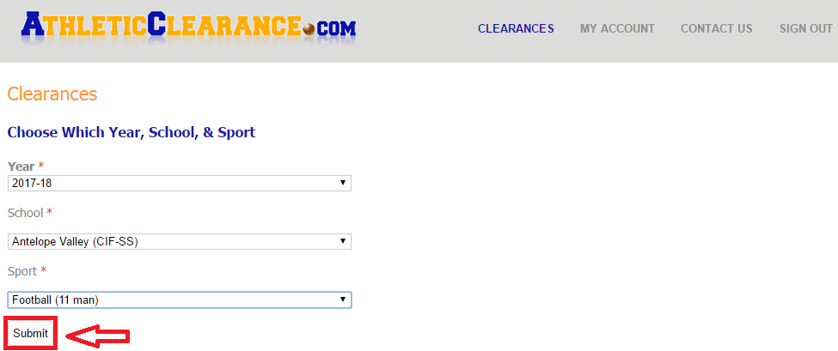 | 6  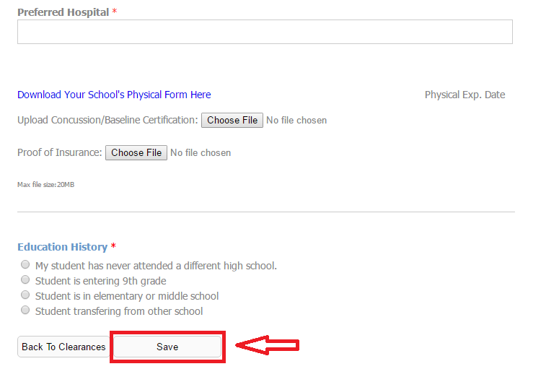
7  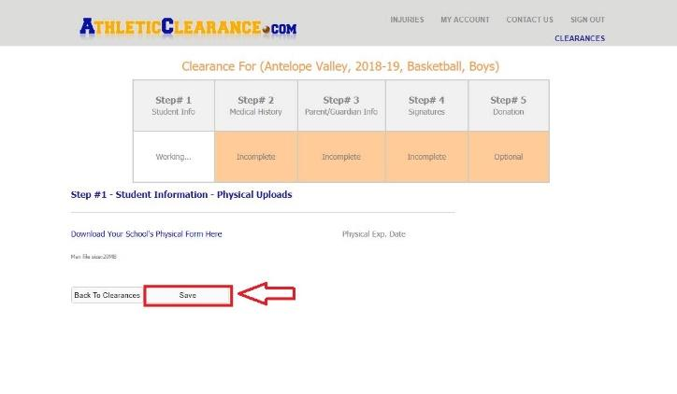 | 8  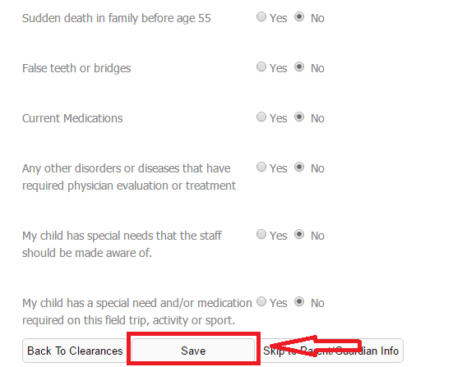
9  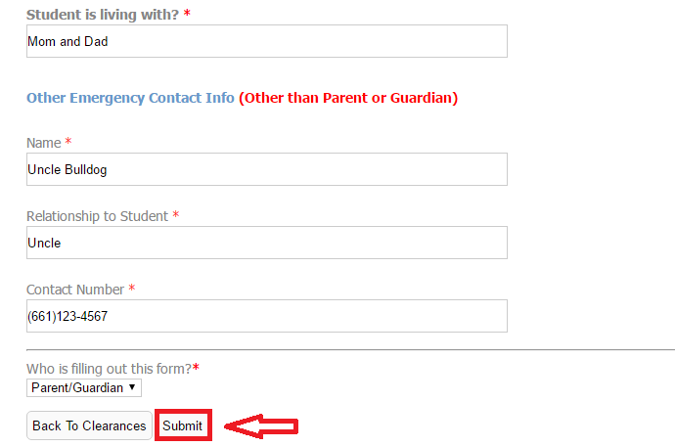 | 10  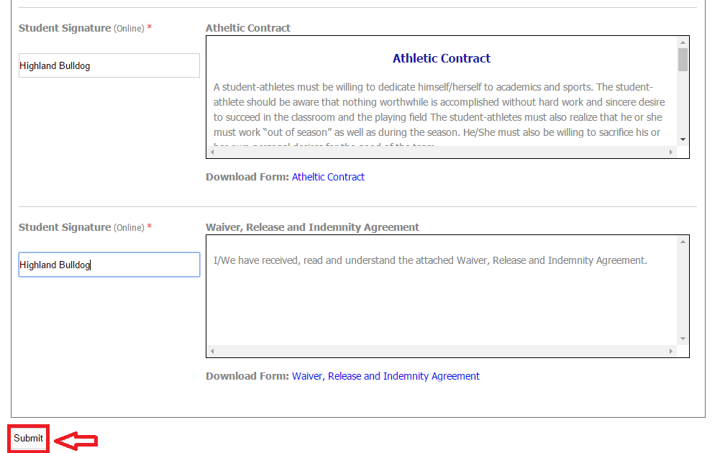
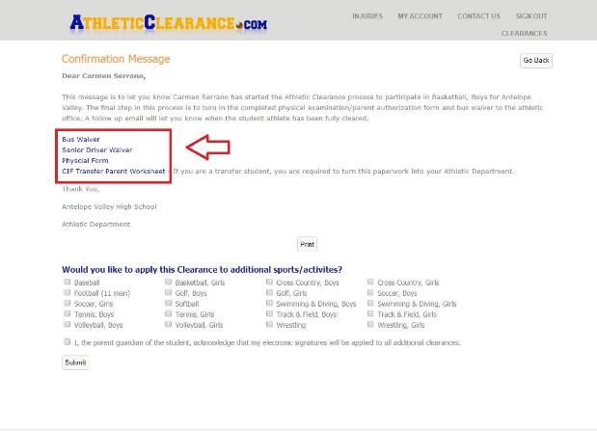  11 | 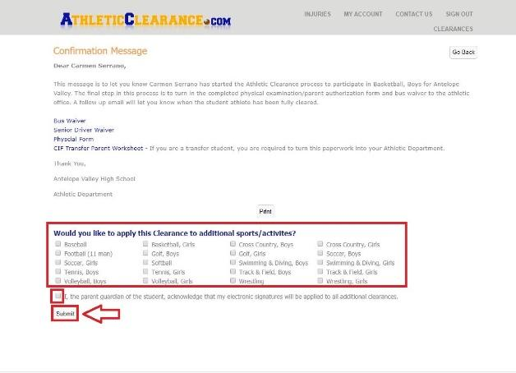  12

*There is also a tutorial video available on how to complete the process on the very first screen of this process.

